JANTA VIDYA MANDIR GANPATRAI RASIWASIA COLLEGE, CHARKHI DADRI
Faculty Profile
Department : Political Science

Name of Faculty |  | Dr. Suresh Kumar |  | 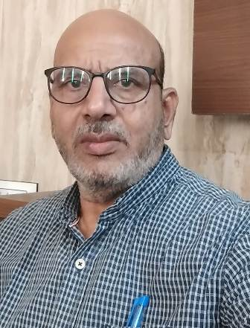
Department |  | Political Science
Designation |  | Associate Professor
Experience |  | 30 years
Contact No |  | 9416980215
Email Id |  | skj01250@gmail.com
Date of Joining |  | 11 July 1994
Educational Qualification |  | M.A, M.Phil. , Ph.D.( Political Science)
Name of Program |  | Year of  Passing | University
PG | M.A.  (Political Science) | 1990 | Maharshi Dayanand University, Rohtak
Ph.D. | Ph.D.  (Political Science) | 1998 | Maharshi Dayanand Saraswati University, Ajmer( Rajasthan)
Net | - | - | -
Other | – | - | -
Research Supervision/Guidance |  | 20-M.Phil. & 1-Ph.D.( Political Science)
Research Publications |  | 16- Research papers Published in Peer-Reviewed and UGC CARE
Books Published |  | 8 (with ISBN number)
Book Chapters |  | 5 (with ISBN number)
Papers Presented in Conferences/ Seminar |  | International: 8 National: 24
Participated in Conferences/ Seminar |  | International: 5 National: 5
No. of Workshops/FDP/Training Programme Attended |  | 5
Major/Minor Research Projects |  | 1(UGC)
Invited Lectures |  | 3 (As Resource Person)
Awards/Honours |  | 3
Membership of Any  Professional/ Statutory Body |  | 2 (Indian Political Science Association and Savitribai Phule Organization for Academic Research & Social Development)
Any Other Achievement |  | - Member, PG (BOS), CBLU Bhiwani  - Ex-Member (UG BOS) MDU Rohtak  - Member Editorial Board Asian Social Science an Academic Journal Published by Canadian Centre of Science and Education.  - Ex-Member Executive Committee, IPSA.  - Acted as Examiner Chhattisgarh Public Commission Raipur  - Acted as Subject Expert- College Level and HBSE Bhiwani.

